March 29, 2023 – Java Project – Thea Gregory 5291240

Today I worked on the following:

* Completed edit delivery guy
* Completed delete delivery guy
* Worked on order food, currently creating the mysql queries to add order to database. MVC part completed.

It was a harder day, I’ve been really pushing myself to keep up and complete the project on time. I think I will, as I’m confident that I finally set up my database the right way and have the proper arrangement of foreign keys and classes needed to efficiently store the data. I feel relieved that delivery guy is done, as it was the last part of administrator left to complete. For the rest of the day, I’m going to complete order food and order history. Then I’ll move on and complete Manager, Restauranteur and Delivery. These shouldn’t take too long as the views are simple and the queries are pretty easy.

Screenshots:

Order food:

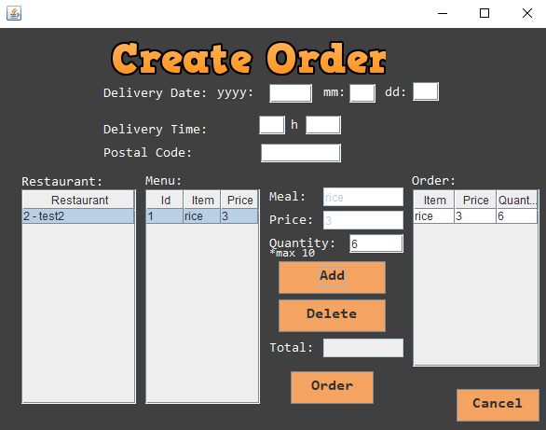

How to get the id of the delivery guy:

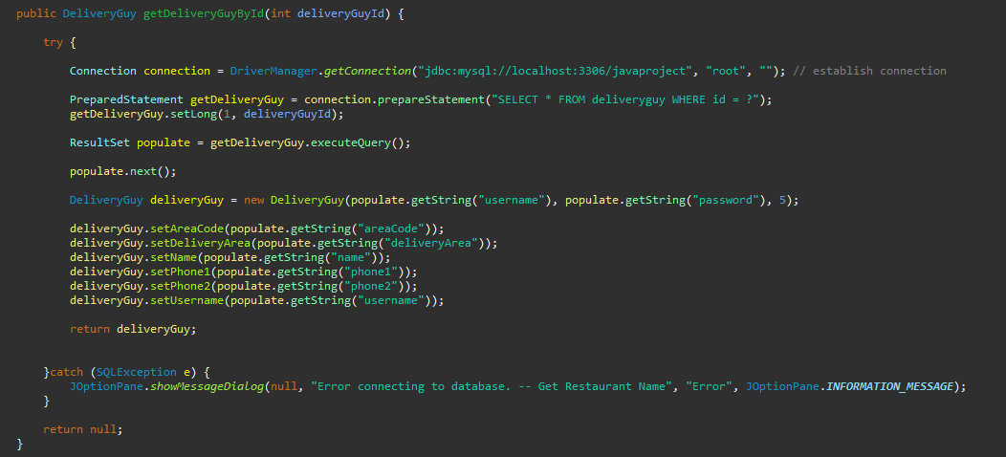

Delete Delivery Guy:

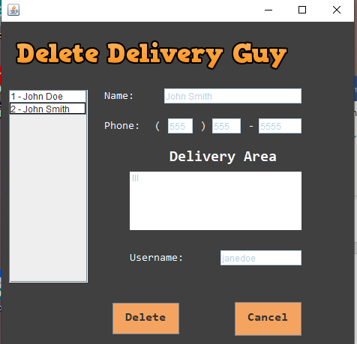

Beginning of code to add new order:

